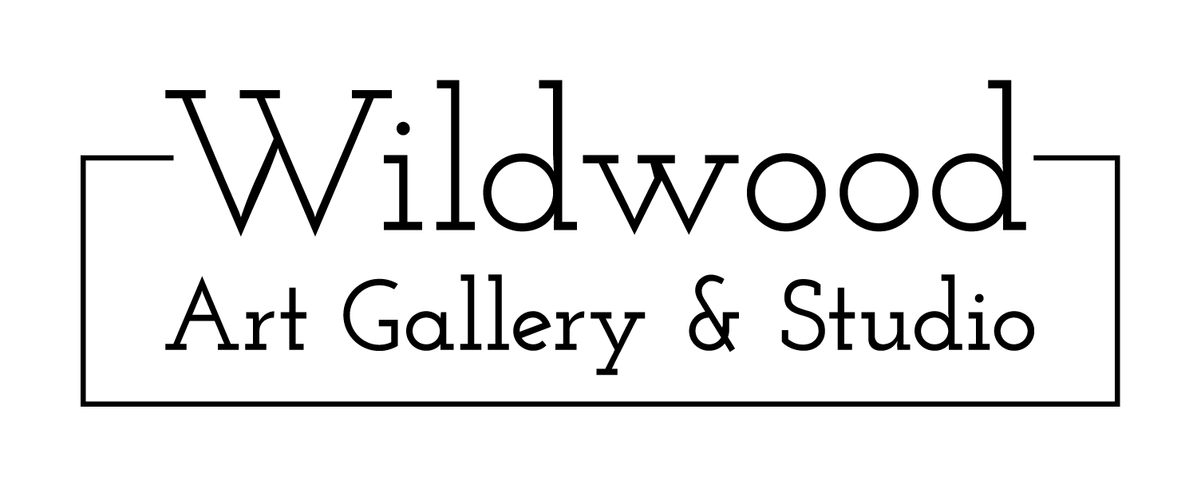
HALDIMAND PHOTOGRAPHY CLUB SHOW | OCT 5 - 26, 2019
Artist Submission Form

Artist Name:

Address:

City & Postal Code:

Phone:

Email:

Website:

HST # (If Applicable):

Instagram:

Facebook (User Name or Art Page):

Submission & Show Details:
- Open to Haldimand Photography Club Members only – showing framed photography only
- We are a child-friendly gallery with regular kid’s classes and therefore discourage the submission of nude works
- Email submission form and images of artwork to info@WildwoodCayuga.com by Sat September 21 for review
- All submissions will be reviewed, and Artists will be notified of accepted works by Mon September 23
- Accepted works must be dropped off at the gallery by or before Sat September 28 during gallery hours
- Show Runs: Sat October 5 - Sat October 26 2019
- Sold work will be subject to a consignment split of 65% to the artist, 35% to Wildwood Art Gallery & Studio
- Payment to Artist for work sold will be made within 30 days of sale date, via e-transfer
- Unsold work must be picked up within a reasonable time after the show is complete

No. | Title | Size (H x W) inches | Medium | Retail Price
1
2
3
4
5

Artist Signature:

